1.  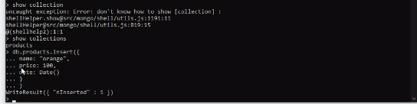   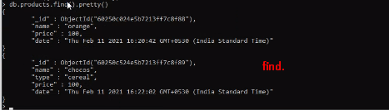 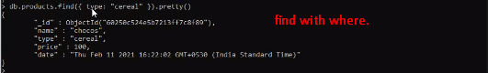  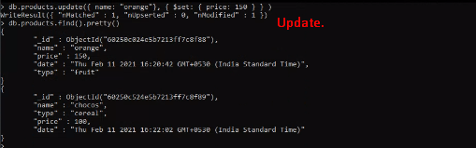
2. updateMany(), insertMany().
3. Cluster is for running multiple nodes which are to scale out your app.